1. Copy and paste the Powershell example code into an empty notepad window.

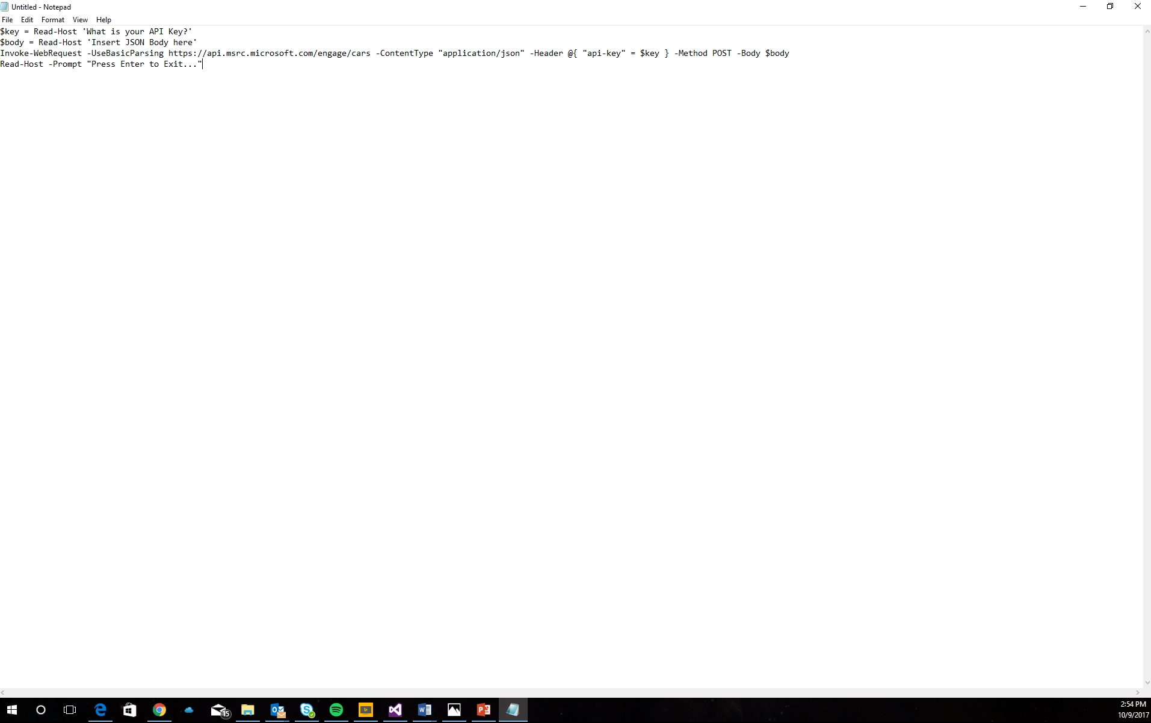

1. Save the notepad file as a .ps1 file.

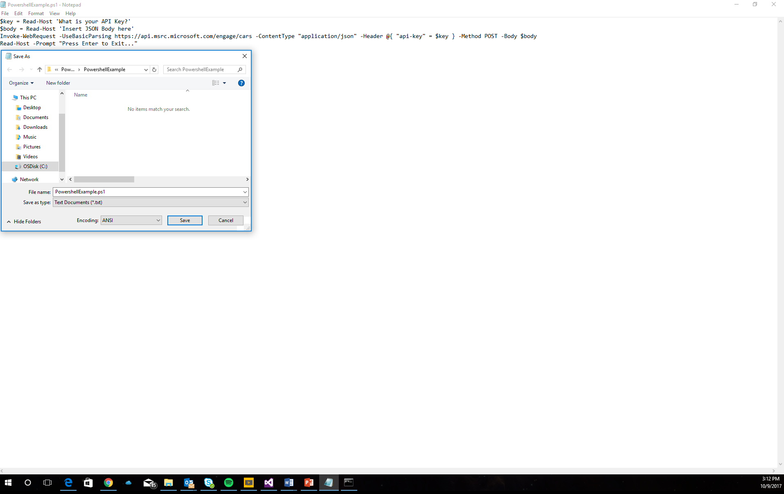

1. Open command prompt and type in “Powershell -NoExit” then your file path including the .ps1 file type. Input your API Key and copy and your personalized JSON body from the GitHub Repository.

